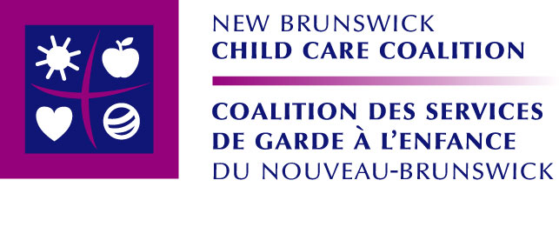

For immediate release

Coalition makes public findings of Mothers Voices Initiative

(Fredericton, N.B.) June 1, 2010 —Today the NB Child Care Coalition launches the third and final phase of the Mother’s Voices Initiative by unveiling the project’s findings. This eighteen month project, funded by Status of Women Canada, began with research, was followed by a series of workshops, and is culminating with the presentation of the project findings.

“We heard mothers share a variety of challenges and barriers that are specific to their community,” said Rachel LeBlanc, workshop facilitator and project coordinator. “We also heard many similarities. The cost of child care, the need for quality and the lack of spaces, especially infant spaces, were common concerns to all communities.”
Workshops were held in seven target communities and reached a total of eighty (80) mothers. The targeted communities were chosen to reflect a diversity of perspectives, including new mothers, mothers who are new to Canada, lone mothers, Anglophone and Francophone mothers and mothers who live in both rural and urban communities.

Workshops included a visioning exercise where participants were invited to determine what child care should look like in their community. Participants then examined three distinct ways that government can fund child care. Finally participants were asked their opinion about which government funding model would best deliver child care in their community.
The three funding models form a continuum which ranges from an individualistic to a systemic approach to government funding, namely: fund the parent, fund the program and fund the system. Currently most government child care funding falls under the fund the parent model.
“It is clear from the project findings that participants believe that the current child care funding model is not meeting their needs.” says Jody Dallaire, Executive Director of the NB Child Care Coalition, “The Coalition will make sure that the voices of project participants are not lost. Parents are the experts when it comes to child care. Their perspective is crucial to good public policy and investment.”

The project findings will be presented this month in Riverview, Rothesay, Bathurst and Caraquet. They will also be used by the NB Child Care Coalition as a tool during the upcoming provincial election.
Amanda Pooley, mother of three children under the age of 5 and project participant, indicated at the press conference: “I wonder if I will ever be able to finish my studies and get my degree. Even if I can find child care for my twin infants and five year-old son, how will I ever be able to afford it as a student-mom?”

Nadine Goguen, project participant and mother of 3 also shares: “I stayed at home with my girls for a few years while my husband worked. I have my MBA and want to work, but a good portion of my salary would go to cover the costs of daycare. We need a funding model that will build a child care system so women do not need to choose between having a family and having a career.”

The Coalition thanks all project participants for their time and expertise.

-30-

A non-profit, membership-based organization that includes both organizational and individual members from across the province, the New Brunswick Child Care Coalition promotes quality, universally accessible, non-profit and publicly funded and regulated child care services, with trained and adequately remunerated staff, for all New Brunswick children who want or need it.

For information or to schedule an interview with a project participant, please contact

Jody Dallaire, Executive Director
New Brunswick Child Care Coalition
(506) 855-8977 (w) / (506) 961-1131 (c)
jody.dallaire@rogers.com

